**EXPERIMENT-14**

**DATE;01-10-2025**

**AIM;** Create a Virtual Hard Disk and allocate the storage using virtual box.

**PROCEDURE;**

**STEP;1** Open VirtualBox and click New to create a VM.

**STEP;2** VM name, type, and version.

**STEP;3** Allocate RAM size for the VM.

**STEP;4** Create a virtual hard disk now.

**STEP;5** Choose VDI, VHD, or VMDK disk format.

**STEP;6** Select Dynamically allocated or Fixed size storage.

**STEP;7** Set the disk size (e.g., 20–50 GB) and click Create.

**IMPLEMENTATION;**

**OUTPUT;**

**STEP 1;** Open VirtualBox and click New to create a VM

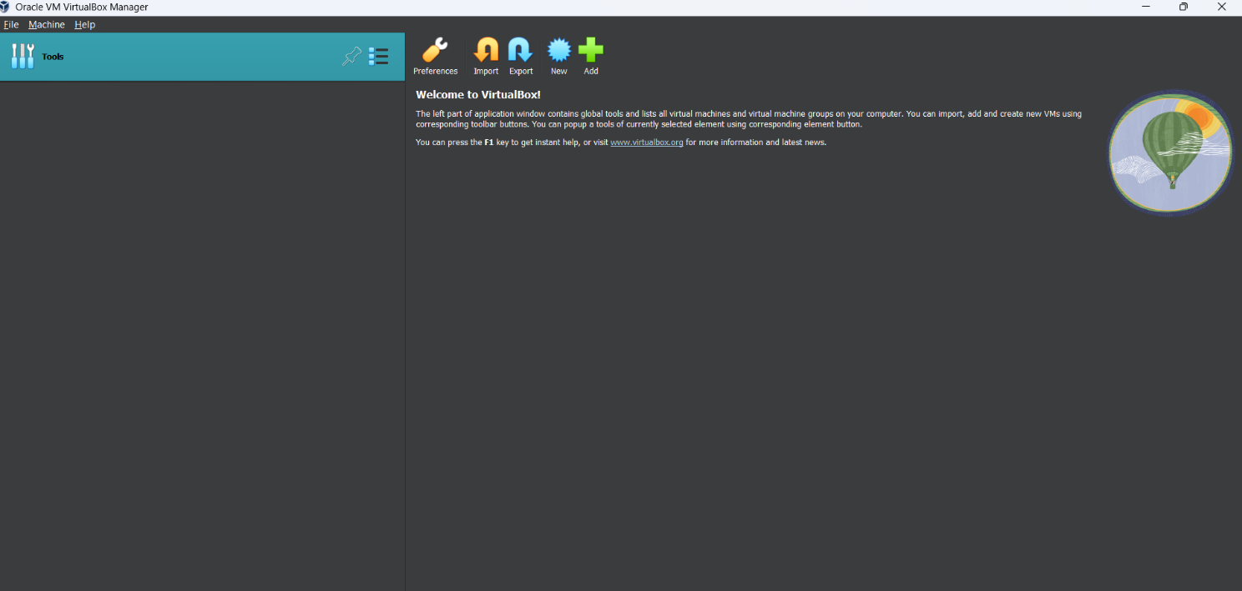

**STEP;2** VM name, type, and version.

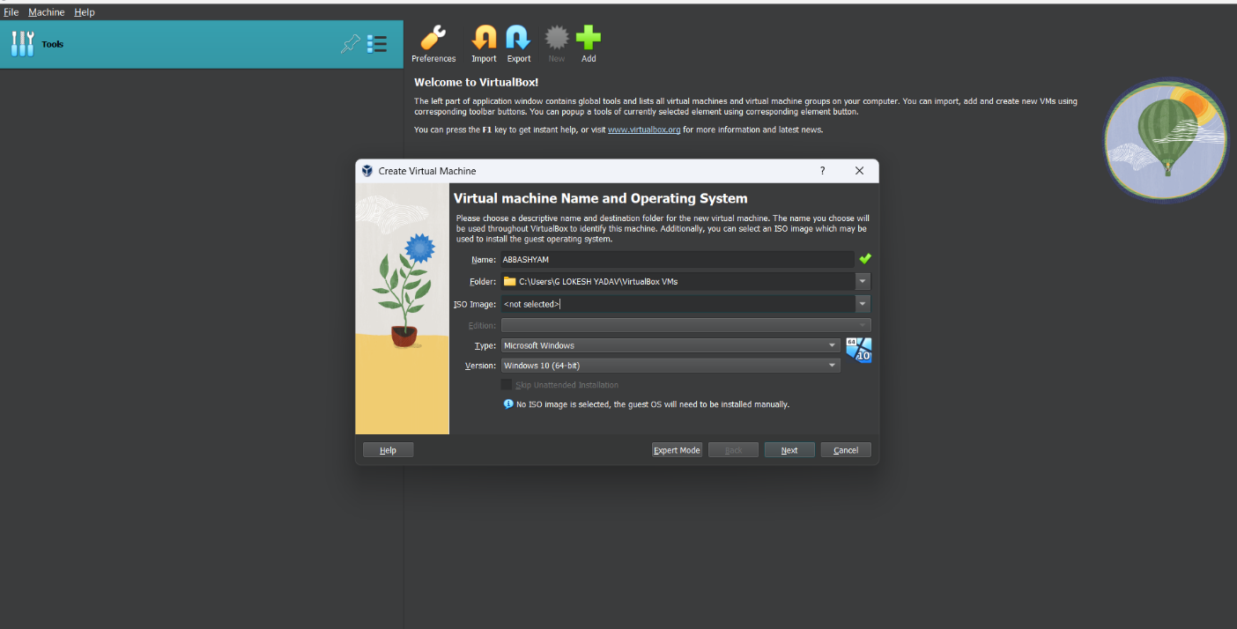

**STEP;3** Allocate RAM size for the VM

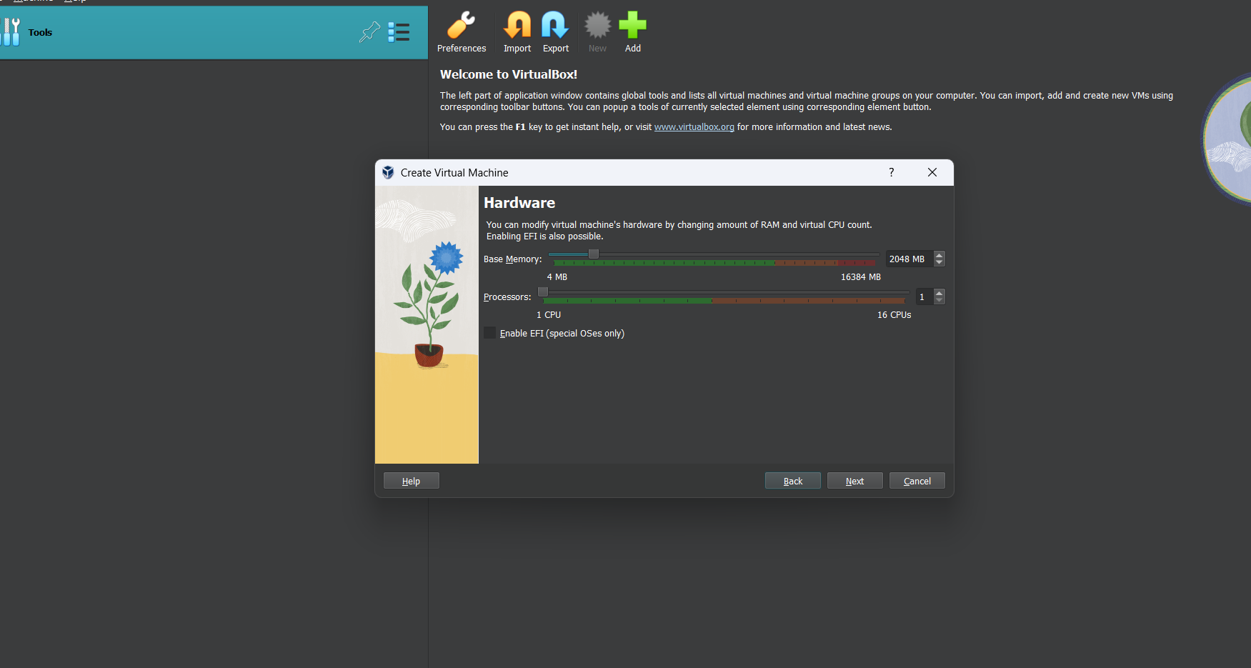

**STEP;4** Create a virtual hard disk now.

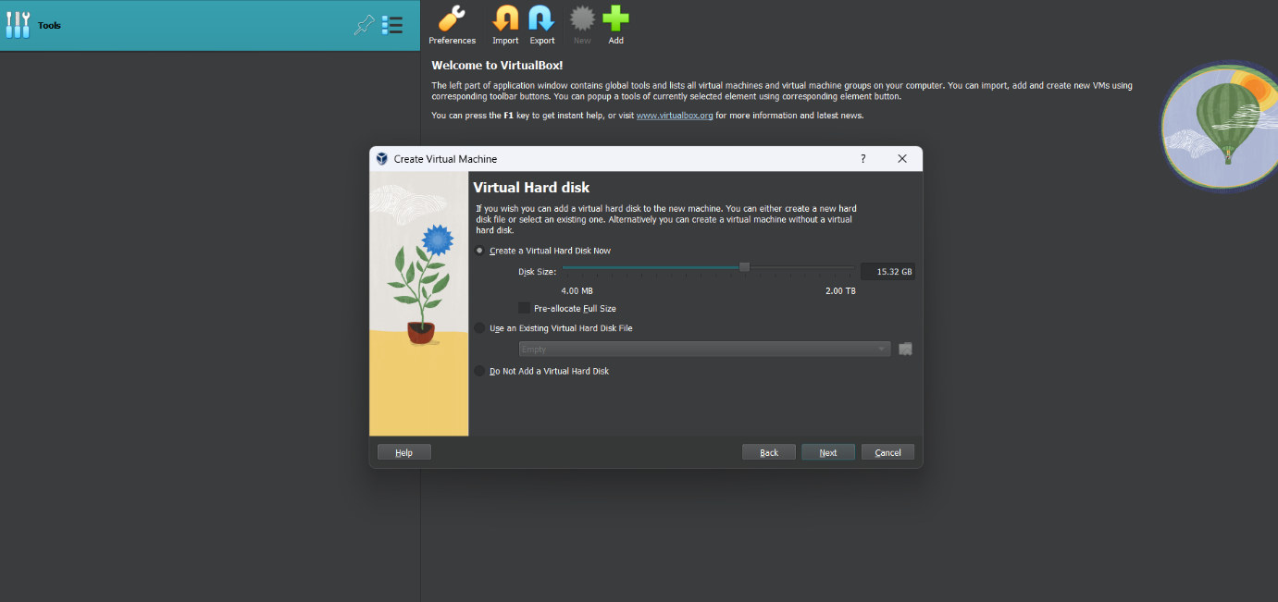

**STEP;5** Set the disk size (e.g., 20–50 GB) and click Create.

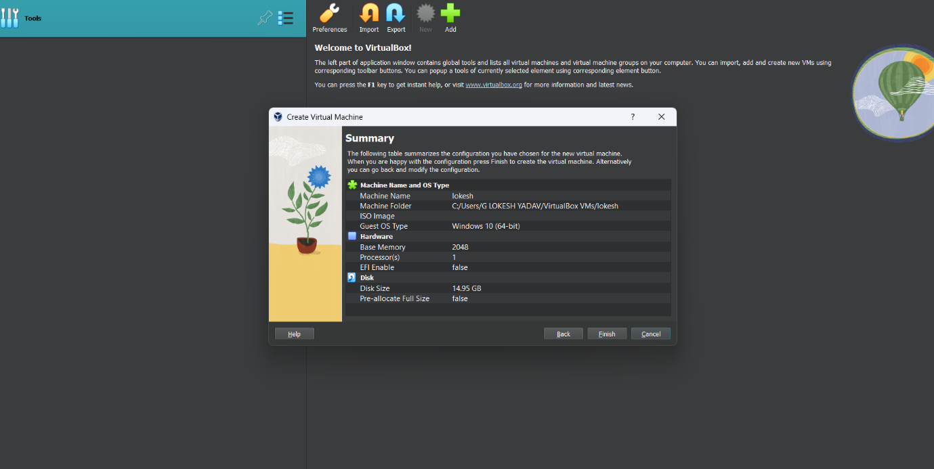

**RESULTS;** successfully created a Virtual Hard Disk and allocate the storage using virtual box.